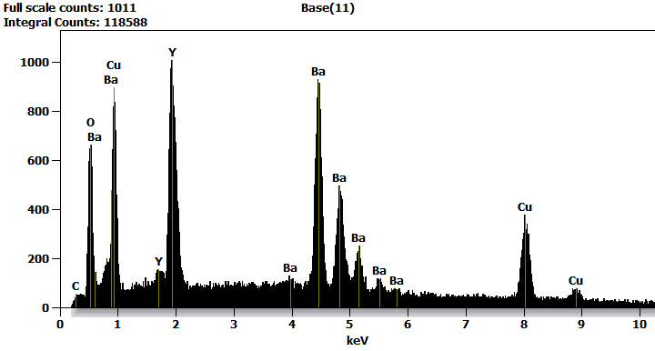

Live Time: 57.7 sec.

Acc.Voltage: 15.0 kV Take Off Angle: 19.5 deg.

Quantitative Results for: Base(11)

|  |  |  |  |
| --- | --- | --- | --- |
| ***Element*** | ***Net***  ***Counts*** | ***Weight %*** | ***Atom %*** |
| ***C*** | 347 | 0.72 | 3.86 |
| ***O*** | 4527 | 7.91 | 31.86 |
| ***Cu*** | 5875 | 29.99 | 30.42 |
| ***Cu*** | 7447 | --- | --- |
| ***Y*** | 4 | --- | --- |
| ***Y*** | 14772 | 19.78 | 14.34 |
| ***Y*** | 0 | --- | --- |
| ***Ba*** | 20684 | 41.59 | 19.52 |
| ***Ba*** | 0 | --- | --- |
| ***Total*** |  | 100.00 | 100.00 |

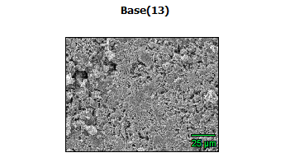

Data Type: Counts

Image Resolution: 512 by 384

Image Pixel Size: 0.32 µm

Map Resolution: 256 by 192

Map Pixel Size: 0.64 µm

Acc. Voltage: 15.0 kV

Magnification: 1000

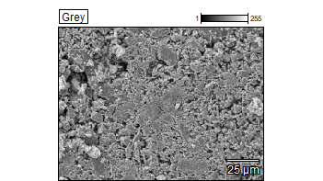 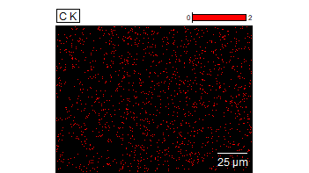

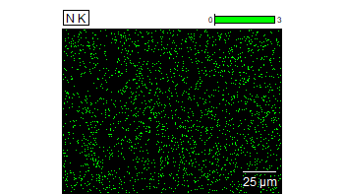 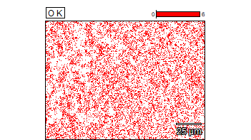

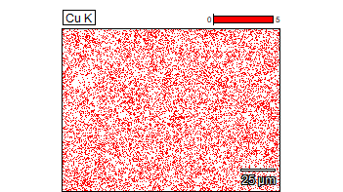 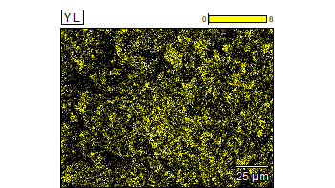



Data Type: Counts

Image Resolution: 512 by 384

Image Pixel Size: 0.32 µm

Map Resolution: 256 by 192

Map Pixel Size: 0.64 µm

Acc. Voltage: 15.0 kV

Magnification: 1000

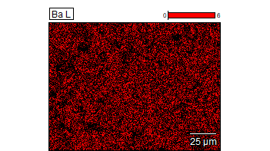

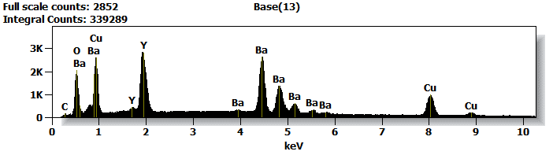

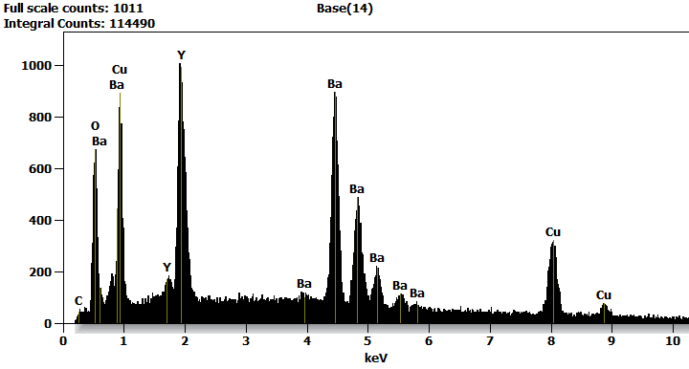

Live Time: 52.8 sec.

Acc.Voltage: 15.0 kV Take Off Angle: 20.1 deg.

Quantitative Results for: Base(14)

|  |  |  |  |
| --- | --- | --- | --- |
| ***Element*** | ***Net***  ***Counts*** | ***Weight %*** | ***Atom %*** |
| ***C*** | 328 | 0.70 | 3.74 |
| ***O*** | 4520 | 8.13 | 32.76 |
| ***Cu*** | 5282 | 28.59 | 29.01 |
| ***Cu*** | 7017 | --- | --- |
| ***Y*** | 7 | --- | --- |
| ***Y*** | 14374 | 20.01 | 14.51 |
| ***Y*** | 0 | --- | --- |
| ***Ba*** | 20023 | 42.58 | 19.99 |
| ***Ba*** | 0 | --- | --- |
| ***Total*** |  | 100.00 | 100.00 |

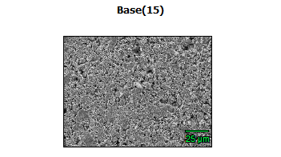

Data Type: Counts

Image Resolution: 512 by 384

Image Pixel Size: 0.32 µm

Map Resolution: 256 by 192

Map Pixel Size: 0.64 µm

Acc. Voltage: 15.0 kV

Magnification: 1000

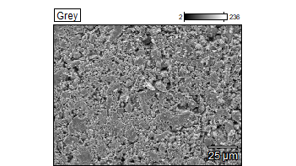 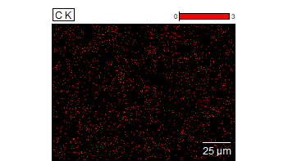

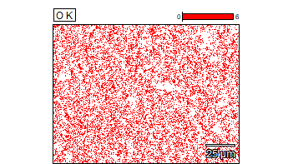 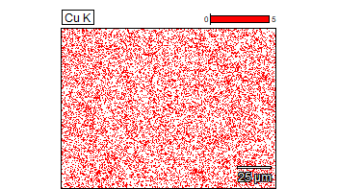

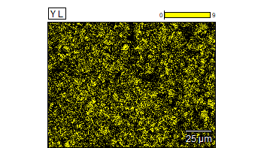 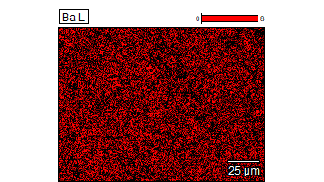



Data Type: Counts

Image Resolution: 512 by 384

Image Pixel Size: 0.32 µm

Map Resolution: 256 by 192

Map Pixel Size: 0.64 µm

Acc. Voltage: 15.0 kV

Magnification: 1000

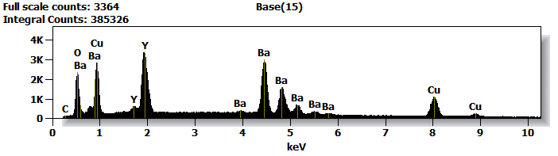

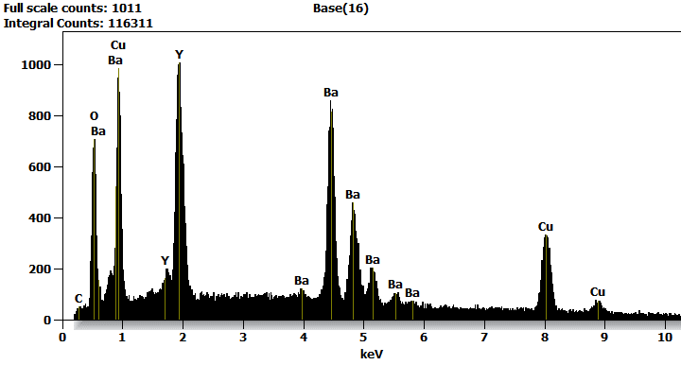

Live Time: 76.2 sec.

Acc.Voltage: 15.0 kV Take Off Angle: 24.8 deg.

Quantitative Results for: Base(16)

|  |  |  |  |
| --- | --- | --- | --- |
| ***Element*** | ***Net***  ***Counts*** | ***Weight %*** | ***Atom %*** |
| ***C*** | 373 | 0.67 | 3.68 |
| ***O*** | 4684 | 7.02 | 28.88 |
| ***Cu*** | 5879 | 32.71 | 33.90 |
| ***Cu*** | 8072 | --- | --- |
| ***Y*** | 9 | --- | --- |
| ***Y*** | 14857 | 18.97 | 14.05 |
| ***Y*** | 0 | --- | --- |
| ***Ba*** | 18908 | 40.63 | 19.48 |
| ***Ba*** | 0 | --- | --- |
| ***Total*** |  | 100.00 | 100.00 |

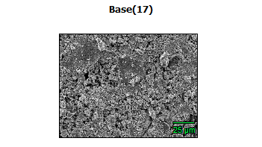

Data Type: Counts

Image Resolution: 512 by 384

Image Pixel Size: 0.32 µm

Map Resolution: 256 by 192

Map Pixel Size: 0.64 µm

Acc. Voltage: 15.0 kV

Magnification: 1000

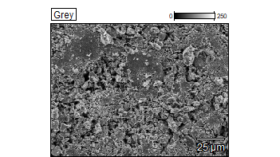 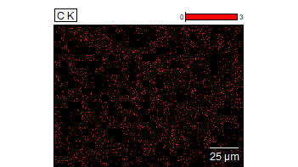

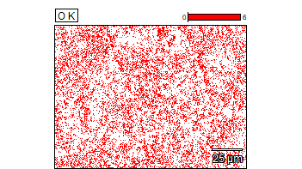 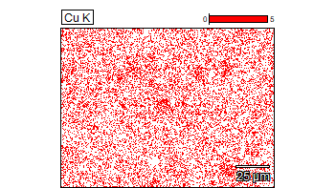

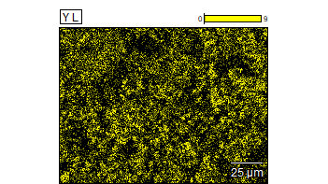 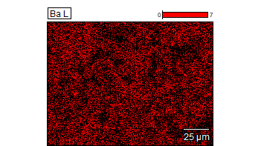



Data Type: Counts

Image Resolution: 512 by 384

Image Pixel Size: 0.32 µm

Map Resolution: 256 by 192

Map Pixel Size: 0.64 µm

Acc. Voltage: 15.0 kV

Magnification: 1000

